Please select your level of proficiency in French
☐A2 ☐B1 ☐average B2
Please insert your photo

First Name: _______________________________________________________
Last Name: _______________________________________________________

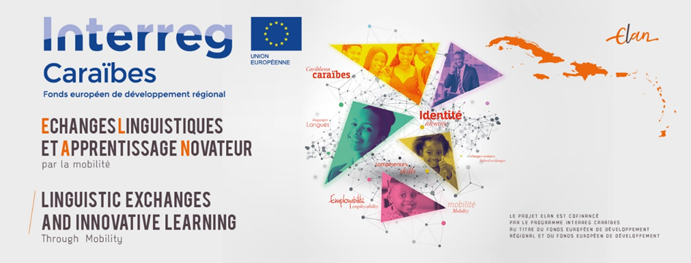
This form is to be completed by nationals of the OECS member states who have A2, B1 or average B2 proficiency in French and who intend on pursuing studies at the Université des Antilles in Martinique or Guadeloupe or any other higher education institution in Martinique.
Please fill out the form in Word, print and sign it where necessary, then scan the form as ONE PDF file named after your surname and first name. The form and required documents should be sent to elan@campusfrance.org and to elan.interreg@gmail.com before 6th September 2020. Each attached document should correspond to ONE PDF file named after your surname, first name, and the type of document (e.g. DOE John - passport).
Photos of documents will not be accepted!
ELAN French Immersion Programme Application Form (ELAN-I)
1.Personal information
Title: | ☐Mr. ☐Mrs. ☐Ms.
Given Name(s): | Given Name(s)
Last Name: | Last Name
Marital status: | ☐Single ☐Married  ☐Divorced ☐Widowed
Date of Birth: | (___/___/___)
City and country of birth: | City  Country
Nationality: | Nationality
Sex: | ☐F ☐M ☐ Other
Profession: | Profession
Personal Address: | Address Line 1  Adress Line 2
City: Country: | City Country
Mailing address (if different from the above): | Mailing adress
Telephone: Home:  Mobile: | Home  Mobile
Email address: | Email

Contact person in case of an emergency
First and Last Name: | First Name Last Name
Relationship: | Relationship
Address: | Address line  City  Country
Telephone: Home:  Mobile: | Home  Mobile
Email address: | Email

What is your current level of French? | ☐A2 ☐B1 ☐average B2
Do you have any DELF/ DALF / TCF/TEF or other French language certificates?  If so state the name of the most recent certificate, the year and the level acquired : | ☐Yes ☐No  If yes  Name (ex DELF…)  Year Level
Have you ever attended classes at the Alliance Française before? | ☐Yes ☐No If yes from  (___/___/___) to (___/___/___)
Most recent degree  Title:  Year:  Institution: | Title  Year Obtained  Institution
Which degree programme will you be applying for at the University/ host institution after the French immersion programme ? Programme: | Programme
Faculty/ Department: | Faculty
Institution: | Name of Higher education Institution
Site: | ☐Martinique ☐Guadeloupe
Level: | ☐Undergraduate ☐Masters
Where did you hear about the Elan immersion programme? | ☐College or University ☐Newspaper ☐Internet ☐Other

DESCRIBE YOUR MOTIVATION FOR APPLYING TO THE IMMERSION PROGRAMME
Click here to enter text.

- Education
Institution | Field of study | Certificate/ diploma/ degree | Country | Year obtained

- Employment/ Work experience
Position | Company/ Organization | Period | Responsibilities

- References
Name | Position | Organization | Contact information (Telephone, email)

Required documents:
- Photocopy of applicant’s passport
- Certified copy of CAPE 2 or A levels
- Certified copy of other degrees
- Official transcripts: emailed to elan@campusfrance.org AND elan.interreg@gmail.com if it is not possible to email, it can be mailed to the address below, however, mailing should be avoided given the current health crisis:
Campus France
INSPE de Martinique
Route du Phare-Pointe des Nègres
BP 678-97262 Fort- de France
- Two letters of recommendation emailed by referees to the above addresses
- French language certificates if any

Please send applications to the following e-mail addresses: elan.interreg@gmail.com and elan@campusfrance.org before 6th September 2020.
Qualified applicants will be invited to an interview for selection.

IMPORTANT NOTICE:
Please note that:
- Pictures of the documents will NOT be accepted
- Each document must be sent as its own SEPARATE PDF document (thank you for NOT merging all you your documents in one PDF document).
- Each PDF document MUST be named as follow: LAST NAME First name – Title of the document (example: DOE John – CAPE Certificate)

Protection of personal data

The requested information is used and conserved only for the processing, follow-up and administration of your application. Only persons in charge of processing the application will have access to it. Under no circumstances will it be communicated to unauthorized third parties.

By submitting your application, you consent to the use and conservation of your personal data for the purposes described above.

In accordance with the Regulation (EU) 2018/1725 of the European Parliament of 23 October 2018 on the protection of personal data and the modified data protection and freedom of information law of 6 January 1978, you have the right to access your personal information, to be informed about the existence and the extent of data processing, to rectify incorrect personal data as the case may be and to oppose further processing on serious and legitimate grounds. If you wish to exercise these rights, please contact elan@campusfrance.org AND elan.interreg@gmail.com

The___/___/20___ Signature

DECLARATION

I, the undersigned ........................................... .................................................................. (insert your full name), certify the accuracy of the information contained in this application form.

I agree to provide the necessary supporting documents for the processing of my application and to participate in satisfaction surveys during or at the end of the immersion programme.

I declare that I have been informed that any misrepresentation on my part will result in the cancellation of my application.

In the event that my application is accepted, I agree to attend classes regularly, to submit assignments as may be required and to make all efforts necessary to obtain at least a B2 level of French.

I declare that I have been informed that:

- I can only apply for the immersion program if I intend on pursuing a degree at a higher education institution in Martinique or at the Université des Antilles (Martinique or Guadeloupe).
- If accepted into the B1 program:
  - I will be required to attend intensive French class and to pass the required B1 exam to continue the programme.
  - The cost of the classes and the DELF exams will be covered by the ELAN project.

- If accepted into the B2 program:
  - I will be required to attend intensive French classes at the Université des Antilles from January and to pass the required DELF exam or TCF in order to register as a regular student in a higher education institution.
  - I am entitled to apply for the ELAN scholarship of 700 € per month while on immersion in the French territory.
  - The cost of the classes and the DELF exams will be covered by the ELAN project.

The……./……./20…...
Signature

Authorization to capture and/or reproduce and/or use image and/or voice

ELAN “Linguistic exchanges and innovative learning through mobility” is a 3-year project co-financed by Interreg Caribbean through the European Regional Development Fund and the European Development Fund. It seeks to improve the command of French and English as foreign languages and to encourage student mobility, training, and school exchange programmes within the Caribbean.
The objective is to reinforce young persons’ skills in order to improve their access to the labor market as well as enhance the attractiveness of territories and finally, to promote a shared Caribbean identity as the basis for an efficient and sustainable regional integration.
In accordance with article 9 of the French Civil Code on intellectual property, we have to ensure that your consent to the use of your photos/recordings is properly recorded. As such, we kindly ask that you carefully read the attached authorization form and that you provide us with your name, address, signature and date of consent if you agree with the terms spelt out in the form.
The signed and dated form has to be sent to elan.interreg@gmail.com and elan@campusfrance.org
The ELAN team would like to thank you for your kind collaboration and remain at your disposal for more information.

Information regarding the processing of your personal data
The ELAN project partners, the Académie de Martinique and Campus France: ("We") request and collect your personal data in order to gain your authorization and ensure that your privacy and image are respected when disseminating your image and your voice for the purpose of promoting the ELAN project. This information is conserved for the time necessary to respect our commitments and our rights. Your information will only be transferred to our authorized technical service providers.
You have the right to access your data or request that it is erased. You also have a right to oppose, a right to rectify and a right to limit the processing of your data. If you wish to exercise any of these rights feel free to contact us at elan.interreg@gmail.com or at elan@campusfrance.org
For more information on these procedures, you can consult our Privacy policy (http://www.elan-interreg.org/politique-de-confidentialite) or contact us at the following email address: elan.interreg@gmail.com or elan@campusfrance.org.

Authorization to capture and/or reproduce and/or use image and/or voice

This form is intended to register the consent and the authorization to capture and/or reproduce and/or use the image and/or voice of the person mentioned below within the framework of the communication actions concerning the Elan project and the valorisation of the project for an unlimited period of time.
I the undersigned (Frist and Last names) .................................................................................................................,
born on the…………………………………………….………………… at ……………………………………………………………………………………,
residing at (address) ................................................................................................................................................,
email ………………………………………………………..………………………………@………………………………………………………………….….
authorize the ELAN project partners l’Académie de Martinique and Campus France: (the "Beneficiaries") to:
- take photographs or audio-visual recordings on which I appear, in the context of the project mentioned above
- use and/or reproduce the photographs and/or audio and/or audio-visual recordings produced by the Beneficiary or third parties in order to illustrate or promote the activities of the ELAN project, on any medium and by any process including via a wired or wireless network, of whatever nature it may be (whether Internet, network, local) and in particular: on paper, on the ELAN project website, on the ELAN project social networks (Twitter and Facebook) and more generally on any existing or future medium.
The beneficiaries of the authorization are expressly forbidden to carry out any illegal exploitation, of your image and / or of your voice likely to compromise your dignity, your reputation or your personal privacy and any other harmful exploitation under the laws and regulations in force.
This authorization is granted free of charge, for any territory and unlimited period of time.
By signing this form:
- you acknowledge that you cannot claim any remuneration for the exploitation of the rights referred to herein.
- you expressly acknowledge that you are not bound by any exclusive contract for the use of your image and/or your voice, or your name.
- you acknowledge that you have been informed that these provisions are brought to your attention, within the framework of implementing the laws relating to the respect of image rights and of private life and in particular article 9 of the French Civil Code.

Express jurisdiction is given to the French courts for any dispute arising from the interpretation or execution of these terms.
Signed in: Signature preceded by the mention “read and approved”:
Date:

Original copy to be sent to the coordinator of the ELAN (elan.interreg@gmail.com and elan@campusfrance.org)

